**Tasks**

**Objective Questions:**

1. What is the total no. of tables present in the data?

**Ans:** One table is present in the dataset .

1. What is the total no. of attributes present in the data?

**Ans:** Total of 35 attributes are present in the dataset.

1. The data consists of some inconsistent and missing values so ensure that the data used for further analysis is cleaned.

**Ans:** Removed a few irrelevant columns:- timeDuration(some irrelevant data as per the description provided in the presentation), isWhiteListUser and queue columns are

ir-relevant (they have single values).

I have cleaned and extracted the data over the following columns:

**chatStatus, createdAT, updatedAt, chatStartTime and chatEndTime, guruName**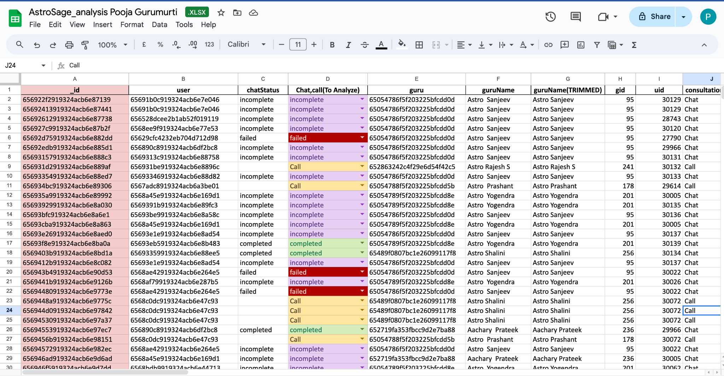

1. What is the average daily call volume over the day by day and what’s the change in it?A screenshot of a computer

   Description automatically generated

**Ans:**

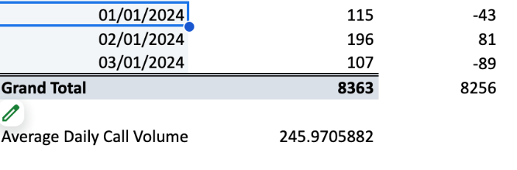

The given pivot table is in the sheet named “Q-4,5,6,9,10,13” of the spreadsheet file. It explains the Daily call volume by counting the number of “call duration” for each day. The Day/day change column is used to find the day-by-day change in the call volume.

Average Daily Call volume = Grand total / No of days => 8363/34 = **245.9705882**

Observations:

* The total call volume over the period is 8363 calls. There are significant fluctuations in the data, with several days showing a large increase and sharp declines.
* There is a sharp drop on **5/12/2023, 8/12/2023, 14/12/2023** . These declines might be due to the issue of technical failures or shortage in staff or other external factors.
* High call volumes will lead to delays in service and users might have missed the opportunities also. In those days company needed to ensure staffing, system capabilities.

1. Which months experienced the highest and lowest call volumes?

**Ans**: In the Pivot table , _id of users has been taken, as _id is unique and consultation type has been set to Call. Month has been extracted from the createdAt from the dataset.

* Set consultation type => call

December -> highest call volume

1. What is the total operational cost for that month?

**Ans**:

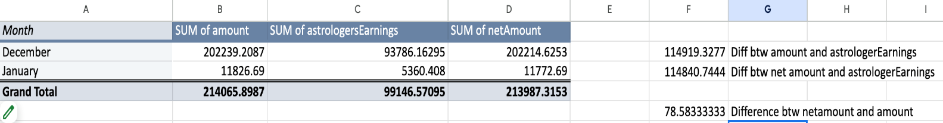

|  |  |  |  |
| --- | --- | --- | --- |
|  | Month | Operational Cost |  |
|  | January | 5360.408 |  |
|  | December | 93786.16295 |  |
|  |  |  |  |

* Operational Cost for that particular month has been extracted from the pivot table which contains Month in rows and Sum of astrologer Earnings in values.
* Operational cost is considered as the astrologer Earnings.
* The operational cost in December is significantly higher than in January.
* December 2023 has increased customer activity than January 2024

1. What is the average number of calls handled per agent per day?

**Ans:**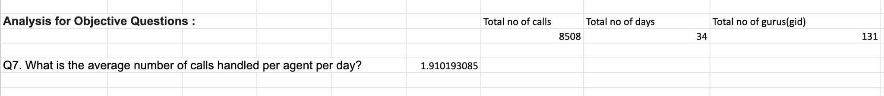

Calculated by extracting Total number of calls, number of days and numbers of gurus.

Total calls/(No. of days * No. of Gurus) = Average call handled per agent per day

* An average call per day per agent is 1.91 which is very low , which indicates that the guru/agent is not fully engaged throughout the day, affecting the productivity of the employee.
* A company can analyze the peak and off-peak call times and adjust the agents/gurus accordingly to prevent the overstaffing or understaffing.

1. How many repeat callers are there, and what percentage of total calls do they represent?

**Ans:** There are a total of 1277 repeat callers.

Percentage of calls represented by repeat callers : 57.3460

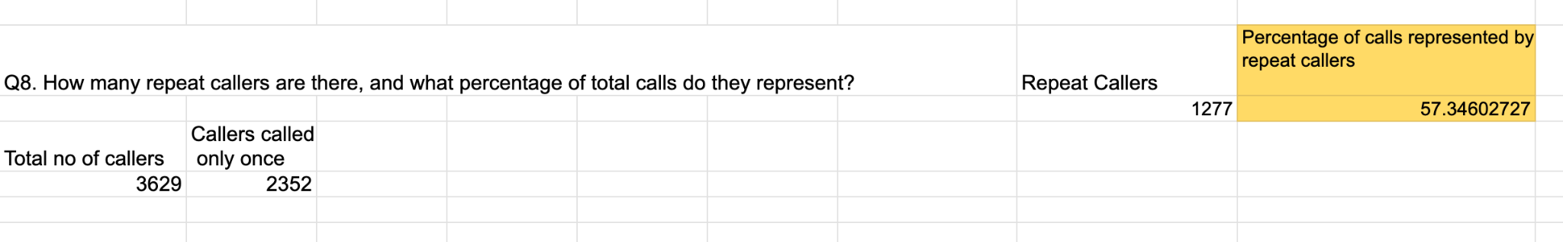

**Steps to solve:**

* Grouped the data of userId in rows in a pivot table and added userId(count) to get the number of calls made by each user.
* COUNT function has been applied to the first column to get the total number of callers.
* COUNTIF function has been applied to get callers who called only once.

**Repeat callers = Total no of callers – Callers called only once**

**Percentage of total calls that repeat callers represent = (Total no. of Calls - Total no. of Callers) /Total no. of calls *100**

1. What is the total sales generated by the call center for each product category?

**

* Total sales has been generated by taking consultationType in rows and sum of amount for each product category.
* Call generates high revenue per user compared to other consultation types.
* Since Call generates more revenue than the Chat , Company can promote Call consultations so that it maximizes the revenue of the Company.

1. How many calls were made for each user ID and guru ID?

**Ans:**

* The pivot table below provides the data of number of calls made by each user and number of calls received by each agent/guru.
* There are many gids and uids having very small counts which indicates less data representation.
* For the values section , CallSid has been taken and rows of the pivot table contain user id and guru id.

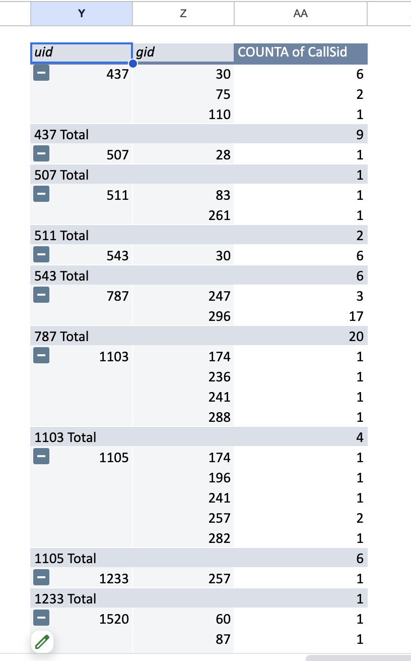

1. What is the correlation between call duration and customer satisfaction?

**Ans:**

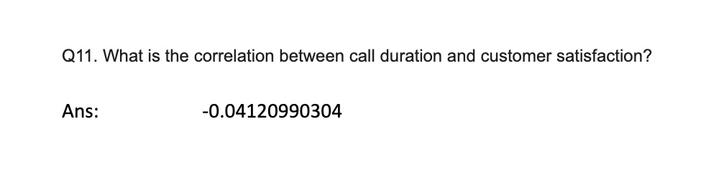

* The **-0.0412** correlation between Call duration and customer satisfaction indicates very weak negative correlation between the two variables.
* The overall average customer satisfaction rating across the call duration is **3.50** which is moderate.
* In this case the value -0.0412 is very close to zero, which indicates that there is no relationship between the variables.

1. Which guru has the highest and lowest customer satisfaction scores?

**Ans:**  Guru with lowest average rating - Tarot Rittika( rating=0)

Guru with highest average rating - Tarot Mystical(rating =7.5)

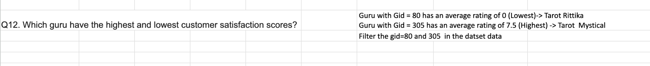

.

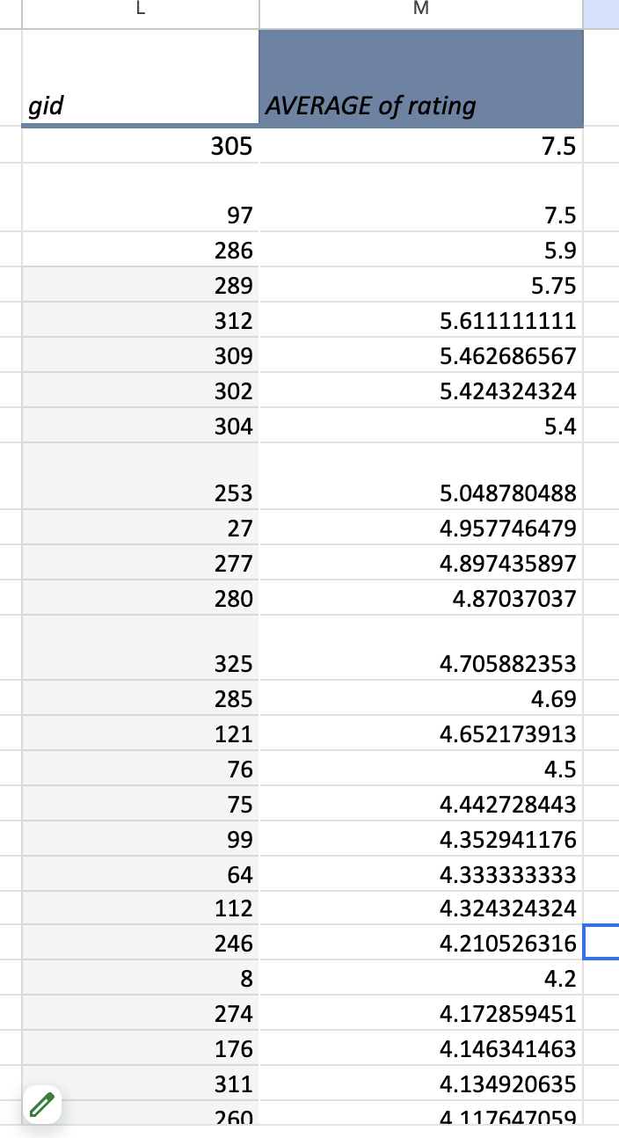

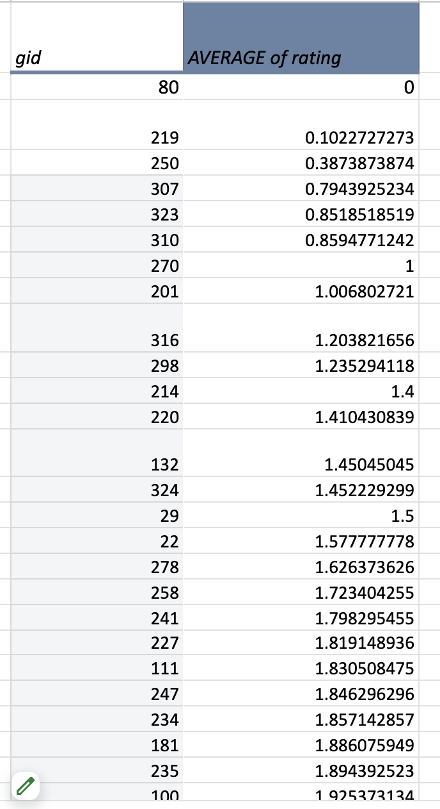

* Created a pivot table and added Gid as rows and Average of Rating as values in order to assess the average rating of each guru/agent, sorted the gid with Average of rating.
* Sorted the gid in ascending order to get the Guru with lowest average rating , and sorted the gid in descending order to get the Guru with highest average rating .
* Applied the Filter for the gid in the dataset to fetch the names of Guru’s with gid=80 and gid=305.

1. What is the average customer satisfaction score by month?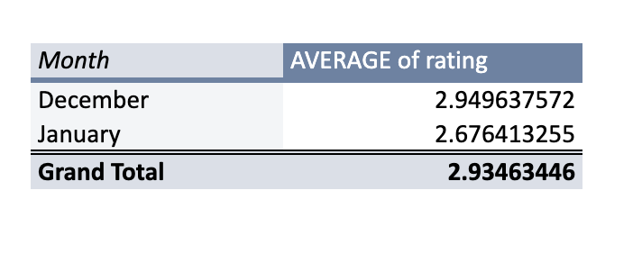

**Ans:**

* The average rating in January is **2.68** , which is lower compared to December and the overall average, which indicates customers are less satisfied with the services provided in January.
* The average rating in December is **2.95** , which is higher than the overall average, which indicates customers are more satisfied with the services provided at the end of the year.
* The overall average rating is **2.93** out of 5, which indicates lower customer satisfaction across the months.

1. How many categorical columns are there in the data? [Search about categorical and continuous data, and try to answer this question]

**Ans:** There are 20 categorical columns in the data.

_id, user, chatStatus, guru, guruName, consultationType, website, refundStatus, queue, isWhiteListUser, chatStartTime, chatEndTime, Date, callChannel, callvrType, callStatus, CallSid , astrologerCallStatus, region, userCallStatus.

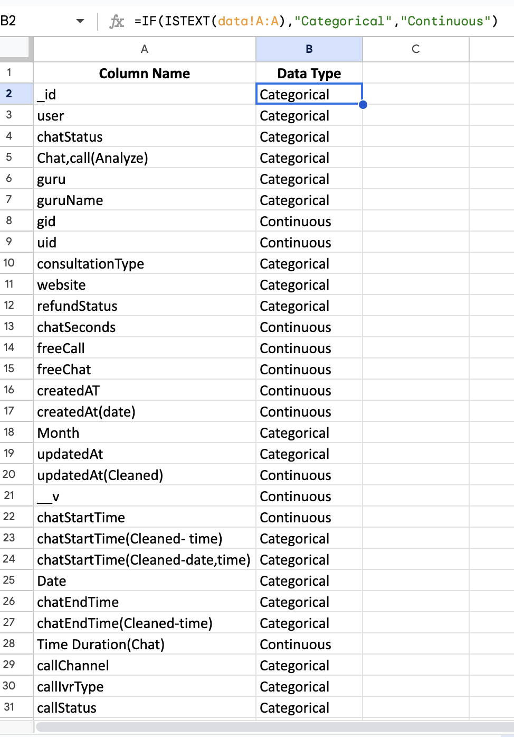

**Subjective Questions:**

1. Should the investment be used to hire more agents, improve training programs, or upgrade call center technology?

**Ans:** Based on the analysis following observations are made: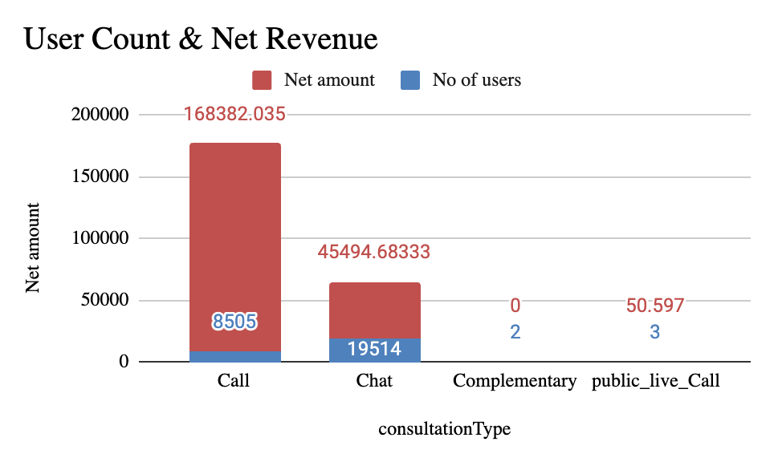

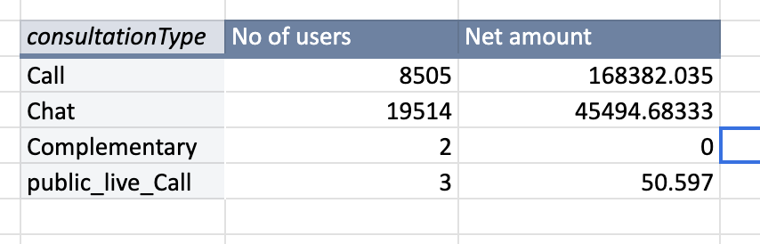

1. This chart is obtained from the pivot table , which has consultationType in rows , users and net amount in values.
2. Number of users in Chat is more compared to the Call, but the revenue generated by call is 78.8% v/s 21.2% over chat. By understanding the substantial difference of Sales between indicates that Customers have a strong preference for “Call” over “Chat”.
3. Out of 8508 total calls only 3450 are completed, which indicates significant calls are not completed, obtained by applying filters to the consultationType and callStatus.
4. Low completion rate suggests that the call center is not meeting its performance targets, so it's necessary to check with the average wait times and call drop rates.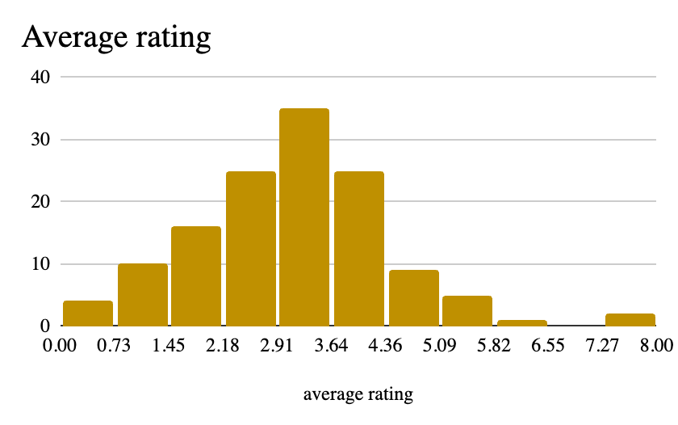

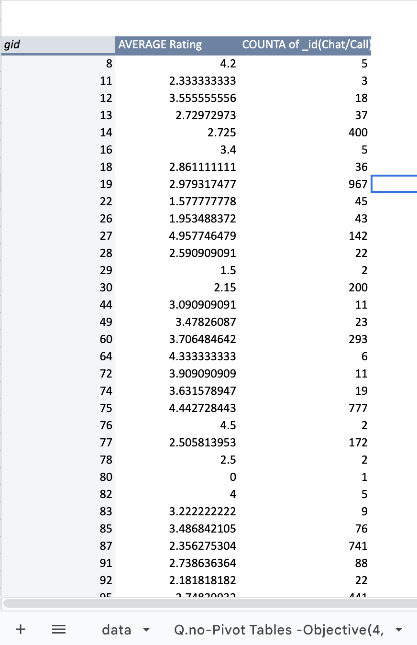

1. This is a pivot table which contains a gid of the Guru, users(_id) for each guru, Guru earnings and the average rating.
2. The “Average rating Distribution” chart is being derived from this pivot table which indicates that a major portion lies below 3.64 out of 8 maximum rating, suggesting that the user experience is low.
3. Some agents earn substantial amounts but they have low ratings, while others have high ratings but lower earnings.
4. The grand total shows a low average rating of 2.93. This suggests that overall customer satisfaction is below average.

**Suggestions:**

* The variance in ratings indicates that some agents might not be performing well due to inadequate training. Improving training programs can help to address specific performance issues, and ensure all agents are equipped with the skills needed to provide high-quality service.
* Hiring more agents might seem like a solution, but the current data suggests performance issues that may not be solved simply by increasing the number of agents. Instead, focus on optimizing the performance of the current workforce.
* The call center's technology should be refined to evenly distribute call volume, ensuring optimal use of the workforce and enhancing overall efficiency.

1. What are the potential risks of each investment option (hiring, training, technology upgrades), and how can they be mitigated?

Name the chart/spreadsheet function you will use for solving the problem?

**Ans:**

Potential Risks for Upgradation of Technology:

1. **High Upfront Costs**: Significant capital is needed to purchase and implement new technology.
2. **Implementation Challenges:** Issues during integration may cause delays or disrupt operations.
3. **Employee Resistance:** Employees may resist or struggle to adopt new systems.
4. **Obsolescence**: Technology can quickly become outdated.

Mitigation Strategies:

1. **Provide training** for employees to adapt to new technology.
2. **Regular updates and maintenance** to avoid obsolescence.
3. **Cost-benefit analysis** to ensure technology aligns with long-term goals.

Potential Risks with agent training:

1. **Time investment**: Employees may spend more time training than working.
2. **Training Costs:** Training programs can be expensive, especially for large teams or specialized skills.
3. **Lack of Employee Engagement**: Employees may not take the training seriously or may not apply the skills learned.

Mitigation Strategies:

1. Use **experienced trainers** with relevant industry expertise.
2. Use **group training** sessions to reduce per-person costs.
3. Make the training **interactive and relevant** to employees’ roles.
4. Ensure training includes **real-world scenarios** employees will encounter.

Potential Risks with Hiring:

1. **High costs**: Salary, benefits, recruitment, and onboarding expenses.
2. **Skill mismatch**: The hired employee may not meet the required skill level.
3. **Turnover**: Hired employees may leave shortly, leading to a costly rehiring process.

Mitigation Strategies:

1. **Conduct thorough interviews and assessments** to ensure proper skill and cultural fit.
2. **Use probation periods** to evaluate new hires before permanent commitment.

Functions that can be utilized in order to facilitate the improvement are:

* **What-If Analysis (Scenario Manager):** This tool allows you to simulate different scenarios, such as changes in turnover rates or salary adjustments, to evaluate their impact on your operations.
* **VLOOKUP/XLOOKUP:** These functions are useful for aligning employees with specific training programs and monitoring their performance after completing the training.
* **NPV (Net Present Value) and IRR (Internal Rate of Return):** Evaluate the financial return of technology investments.
* **SUM and AVERAGE:** Track and average costs associated with technology upgrades
* **IF**: For scenario modeling.

Visualization Tools:

* **Bar Charts**: Compare costs and performance metrics.
* **Line Charts**: Track trends over time.
* **Pie Charts**: Show distribution of costs.
* **Gantt Charts**: Plan and visualize project timelines.

1. How does AstroSage call center performance compare to that of AstroGuru in terms of average call volume, customer satisfaction, and agent performance?Will you use any aggregation function or a visualization here to solve the problem?

**Ans:** AstroGuru’s data not provided.

1. How can the call center improve its handling of peak call periods to ensure high customer satisfaction?

Mention the functionality which you will use for giving the suggestions, will it be any

aggregate function or a visualization?

**Ans:**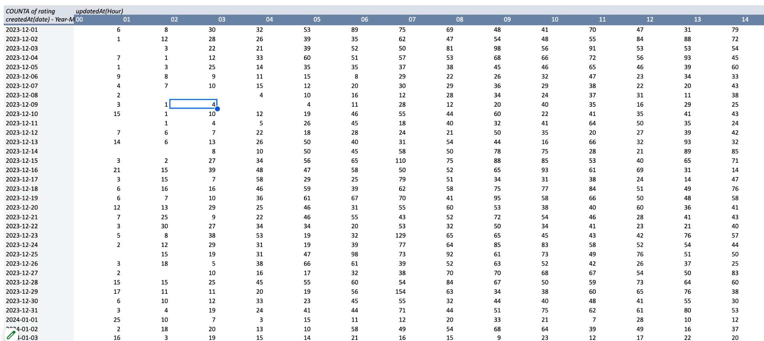

**Insights Drawn:**

* updatedAt(Hour) has been extracted from the updatedAt(Cleaned) column from the dataset [=RIGHT(left(S2,13),2)].
* The pivot table has **createdAt in rows** , **updatedAt(Hour) in columns** , **rating(Customer satisfaction) in values** and **consultationType in Filters**.
* The call center experiences peak traffic around the hours of 03:00, 04:00, 05:00, 06:00, and 07:00, with average counts ranging from 33 to 55 calls. These hours have the highest call volumes. Therefore , more agents have to be scheduled during the peak hours(3:00-7:00) and fewer during off-peak times.
* **Identifying Peak Call Hours**: The data indicates that certain hours, particularly between **6 AM** and **10 AM**, consistently show high call volumes, with peaks often exceeding **100 calls**. For example, on **December 15**, there were **110 calls** during this peak time. Recognizing these patterns allows the call center to anticipate busy periods.
* **Staffing Optimization**: To effectively manage peak call volumes, the call center should adjust staffing levels accordingly. Increasing the number of agents available during high-demand hours can significantly reduce wait times and ensure that customer inquiries are handled promptly, enhancing the overall customer experience.
* **Training and Resources**: With peak periods resulting in increased call complexity and volume, providing targeted training for agents can empower them to resolve issues more efficiently. Additionally, ensuring that agents have access to adequate resources, such as FAQs or troubleshooting guides, can help expedite the resolution process.

**Suggestions:**

* Need to upgrade call center technology to include advanced call routing systems that can distribute calls more efficiently based on current agent availability and call volume. This can help in managing peak periods effectively.
* Have to gather the feedback from customers regarding their experiences during peak times to identify areas for improvement.
* Train the agents specifically for handling high volume periods efficiently.
* Hours with extremely high call volumes (e.g., 06:00) may lead to longer wait times and reduced customer satisfaction, so this issue can be handled by the chatbots.
* December shows consistently high call volumes, peaking towards the end of the month. Can hire part-time or on-demand agents who can be called in during peak times to handle the increased call volume.

1. Based on historical data, what strategic initiatives should be prioritized to improve overall efficiency and customer satisfaction?

**Ans:**

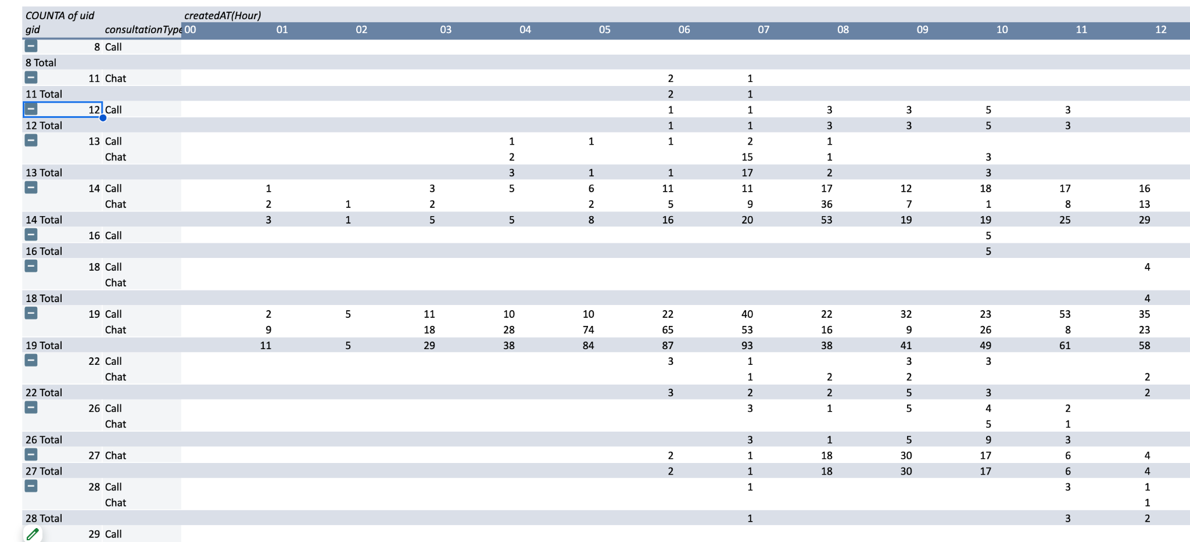

* The first pivot table has **createdAt in rows** , **updatedAt(Hour) in columns** , **rating(Customer satisfaction) in values** and **consultationType in Filters**.
* The second pivot table represents the Gurus gid , Call/chat received by the guru in rows , createdAT(Hour) in columns to get how many calls/chats received by a particular Guru at a particular Hour, uid is the user id in values.
* The average ratings across agents range from 0 to 7.5, indicating significant variability in performance. The highest rating (7.5) belongs to an agent with only 2 interactions, suggesting that the sample size may not accurately represent consistent performance.
* Agents such as 75, 27, and 253 show high average ratings combined with substantial call volumes, suggesting they are effectively managing both quality and quantity.
* A few agents are handling a disproportionately high number of calls (e.g., Agents 75 and 19), which may lead to burnout. This workload imbalance needs addressing to maintain morale and service quality.
* The call center experiences peak traffic around the hours of 03:00, 04:00, 05:00, 06:00, and 07:00, with average counts ranging from 33 to 55 calls. These hours have the highest call volumes. Therefore , more agents have to be scheduled during the peak hours(3:00-7:00) and fewer during off-peak times.
* **Identifying Peak Call Hours**: The data indicates that certain hours, particularly between **6 AM** and **10 AM**, consistently show high call volumes, with peaks often exceeding **100 calls**. For example, on **December 15**, there were **110 calls** during this peak time. Recognizing these patterns allows the call center to anticipate busy periods.
* **Staffing Optimization**: To effectively manage peak call volumes, the call center should adjust staffing levels accordingly. Increasing the number of agents available during high-demand hours can significantly reduce wait times and ensure that customer inquiries are handled promptly, enhancing the overall customer experience.

**Based on past call center data and the objective of boosting overall efficiency and customer satisfaction, the following strategic initiatives should be emphasized:**

1. **Optimize Call Routing and Management:**

**Analysis:**

* Historical data often reveals peak call times, frequent call reasons, and patterns in call volumes.
* Inefficiencies in call routing and management can lead to longer wait times and increased call handling time.

**Actions:**

* **Implement Intelligent Call Routing:** Use data to set up rules for routing calls to the most appropriate agents based on skill set and previous interaction history.
* **Adjust Staffing Based on Predictive Analytics:** Use historical data to forecast call volumes and adjust staffing levels accordingly to meet demand without over or understaffing.
* **Enhance IVR Systems:** Design and refine IVR systems to handle routine queries efficiently, directing complex issues to the right agents.

### **Leverage Technology for Efficiency:**

**Analysis:**

* Historical data may show inefficiencies related to manual processes and outdated technology.
* Implementing modern technology can streamline operations and improve service delivery.

**Actions:**

* **Adopt AI and Chatbots**: Deploy AI-driven chatbots to handle routine inquiries and free up agents for more complex issues.
* **Utilize CRM Systems**: Integrate CRM systems to provide agents with comprehensive customer data and interaction history for more personalized service.
* **Implement Real-Time Analytics**: Use real-time analytics to monitor performance and make data-driven decisions to optimize call center operations.

### **Enhance Agent Performance and Satisfaction:**

**Analysis:**

* Data analysis may reveal trends in agent performance and common areas where agents struggle.
* Agent satisfaction directly impacts performance and customer interactions.

**Actions:**

* **Implement Performance Metrics:** Use historical data to set clear performance metrics and benchmarks for agents, such as average handle time, FCR, and customer satisfaction scores.
* **Provide Ongoing Training and Development:** Offer regular training sessions and workshops to address skill gaps and keep agents updated with best practices.
* **Introduce Coaching and Feedback:** Use performance data to provide constructive feedback and one-on-one coaching to improve individual agent performance.

### **Enhance Customer Feedback and Experience:**

**Analysis:**

* Historical data may highlight areas where customer satisfaction is lacking and provide insights into common customer pain points.

**Actions:**

* **Conduct Post-Interaction Surveys:** Implement surveys to gather immediate feedback after interactions and identify areas for improvement.
* **Analyze Customer Feedback:** Regularly review and analyze customer feedback to identify trends, issues, and opportunities for enhancing the customer experience.
* **Implement Customer Experience Improvements:** Use feedback to make data-driven decisions on improving processes, policies, and service delivery.

### **Selected Training for Poor Performing Agents:**

**Analysis:**

* Analyzing the historical data, it will be seen that there are some agents whose failure rates are very high, and the customers’ ratings are also poor. There is much that targeted training can do to enhance their performance, decrease call failure rate, and increase customers’ satisfaction.

**Actions:**

* Find the agents with low ratings and agents with many failures.
* It is necessary to assess changes in performance after training so that it is possible to determine whether the training was beneficial.
* Create effective training sessions based on the employees’ need for improvement in such areas as communication skills, problem-solving skills, and technical knowledge.

**Suggestions for Improvement**

1. **Targeted Training**:
   * Implement focused training sessions for underperforming agents to enhance their skills and address specific areas of weakness.
2. **Workload Management**:
   * Reassess the distribution of calls among agents. Implementing a system that dynamically assigns calls based on current workload and performance metrics can help balance the load and reduce burnout risk.
3. **Incentives for High Performers**:
   * Recognize and reward agents with high ratings and performance. This can boost morale and motivate other agents to improve.

4. **Feedback Mechanism**:

* + Encourage feedback from agents about their workloads and any challenges they face.

1. What can be the key factors contributing to high customer satisfaction scores, and how can these be leveraged to improve overall performance?

What is the basis for the suggestions? And mention how you decide if the satisfaction score affects the ratings?

**Ans:** 

**Insights Drawn:**

* updatedAt(Hour) has been extracted from the updatedAt(Cleaned) column from the dataset [=RIGHT(left(S2,13),2)].
* The pivot table has **createdAt in rows** , **updatedAt(Hour) in columns** , **rating(Customer satisfaction) in values** and **consultationType in Filters**.
* The call center experiences peak traffic around the hours of 03:00, 04:00, 05:00, 06:00, and 07:00, with average counts ranging from 33 to 55 calls. These hours have the highest call volumes. Therefore , more agents have to be scheduled during the peak hours(3:00-7:00) and fewer during off-peak times.
* **Identifying Peak Call Hours**: The data indicates that certain hours, particularly between **6 AM** and **10 AM**, consistently show high call volumes, with peaks often exceeding **100 calls**. For example, on **December 15**, there were **110 calls** during this peak time. Recognizing these patterns allows the call center to anticipate busy periods.

### **To analyze customer satisfaction ratings and identify key factors impacting them in relation to call volume and peak hours, follow these steps:**

### **1. Data Segmentation**

### **Segment by Hour:** Analyze ratings segmented by each hour of the day, particularly focusing on the peak hours (03:00 to 07:00) and the busy periods (06:00 to 10:00).

### **Consultation Type Analysis:** Use the consultation type filter to break down ratings further, identifying which types of consultations yield higher or lower satisfaction scores.

### **2. Statistical Analysis**

### **Correlation Analysis:** Calculate correlation coefficients between call volume and customer satisfaction ratings to see if higher call volumes negatively affect ratings. Look for patterns during peak hours.

### **Trend Analysis:** Use time series analysis to identify trends in ratings over time, especially during peak traffic days. Compare ratings during high call volume days versus low call volume days.

### **3. Rating Distribution Examination**

### **Rating Histograms:** Create histograms of customer satisfaction ratings during peak and off-peak hours to visualize distribution. This can reveal if there are more extreme ratings (highs or lows) during busy times.

### **Average Ratings Calculation:** Calculate average ratings for each hour and consultation type to identify which combinations yield the highest and lowest satisfaction.

### **4. Identifying Key Factors**

### **Agent Performance:** Analyze if certain agents or teams consistently receive higher ratings during peak hours, which might indicate effective handling of calls.

### Response Time: Investigate the relationship between average response or handling time and customer satisfaction ratings to see if quicker responses correlate with higher ratings.

### **Resolution Rates:** Look into the first call resolution rates during peak times. Higher resolution rates might correlate with higher satisfaction.

### **5. Customer Feedback Analysis**

### **Text Analysis of Feedback:** If qualitative feedback is available, conduct text analysis to identify common themes in positive and negative feedback. Tools like sentiment analysis can help in this regard.

### **Common Issues:** Identify recurring issues or themes in the comments associated with low ratings. This can help pinpoint specific areas for improvement.

### **6. Visualization**

### **Heat Maps:** Create heat maps to visualize the relationship between call volume, time of day, and ratings. This can highlight peak times that correlate with lower satisfaction.

### **Scatter Plots:** Use scatter plots to visualize the relationship between call volume and ratings for different consultation types, helping to identify trends.

### 

### **Determining If Satisfaction Scores Affect Ratings:**

To assess if satisfaction scores impact ratings, follow these steps:

1. **Correlation Analysis**
   * Spreadsheet Function: Use the CORREL function to determine the correlation between satisfaction scores and ratings.
   * Basis: A high positive correlation indicates that higher satisfaction scores generally lead to higher ratings.
2. **Segmentation Analysis**
   * Spreadsheet Function: Use FILTER or QUERY functions to segment data by customer demographics or interaction types and assess how satisfaction affects ratings within different segments.
   * Basis: Understanding how satisfaction scores impact ratings across different customer segments can provide more targeted improvement strategies.
3. **Performance Metrics Comparison**
   * Spreadsheet Function: Use AVERAGE, MEDIAN, and STDEV to compare performance metrics of high and low satisfaction scores.
4. How should the call center balance the workload among agents to ensure optimal performance and avoid burnout?

Mention your approach and spreadsheet function for the answer?

**Ans:**

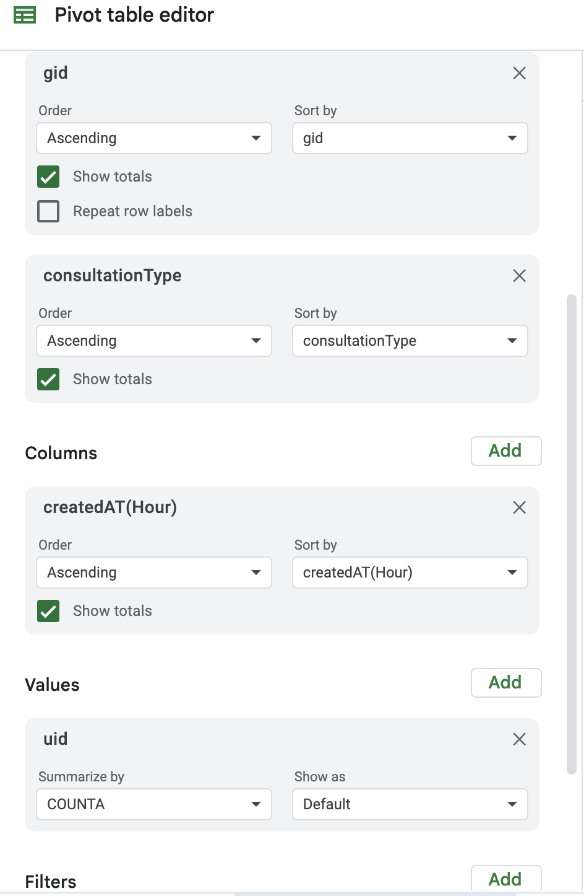

* The pivot table represents the gurus gid , Call/chat received by the guru in rows , createdAT(Hour) in columns to get how many calls/chats received by a particular Guru at a particular Hour, uid is the user id in values.

### **Key Insights:**

1. **Peak Hours Identification**: The data shows clear peaks in call volume, particularly during specific hours (e.g., late afternoon and evening). This suggests a need for increased staffing during these times.
2. **Consultation Type Variation**: There are significant differences in the volume of calls and chats across consultation types (e.g., calls vs. chats). This indicates the need to tailor agent training and assignment based on specific consultation types.
3. **Agent Utilization Rates**: Some agents handle a significantly higher number of calls or chats compared to others. This imbalance can lead to burnout for high-utilization agents and disengagement for low-utilization ones.
4. **Response Time and Quality Metrics**: While the data doesn't provide explicit response times, the high volume during peak hours may affect response quality, leading to decreased customer satisfaction.

**Maintain Balanced Workload:**

* **Action:** Ensure that astrologers are not overwhelmed by high call/chat volumes, which can negatively impact service quality.
* **Overburdened Agents:** Identify agents who are consistently overworked or show signs of burnout, such as higher stress levels or declining performance.
* **Top Performers:** Recognize agents who consistently perform well and those who handle a high volume of calls efficiently.
* **Workload Distribution:** Regularly review metrics such as call volume, average handling time, and agent productivity to understand how workloads are distributed.
* **Performance Data:** Analyze data on call durations, completion rates, and customer feedback to identify trends and potential issues.

Spreadsheet functions to automate the monitoring of workload and performance:

* **Average Calculation**: =AVERAGE(range)
* **Over/Under Load Status**: =IF(COUNTA > Average_Workload*1.2, "Overloaded", IF(COUNTA < Average_Workload*0.8, "Underloaded", "Balanced"))
* **Performance Monitoring**: =IF(AVERAGE_RATING < threshold, "Monitor", "Stable").

1. What new technologies or tools could be implemented to enhance call center operations and customer service?

**Ans:**

1. Artificial Intelligence (AI) and Chatbots

* Benefits: AI-powered chatbots can handle simple queries 24/7, reducing wait times and increasing efficiency. They can also escalate complex issues to human agents.
* Example Tools: IBM Watson Assistant, Drift, Intercom.
* Enhancement: Automates routine tasks, improves first contact resolution, and offers real-time support.

1. Interactive Voice Response (IVR) Systems

* Benefits: IVR systems allow customers to self-serve by navigating automated menus to resolve their issues or route them to the correct department.
* Example Tools: Genesys, Avaya, Cisco Unified Contact Center.
* Enhancement: Streamlines call routing, reduces agent workload, and enhances the customer experience by resolving issues quickly.

1. Customer Relationship Management (CRM) Systems

* Benefits: CRMs track customer history, preferences, and interactions, enabling agents to provide personalized support.
* Example Tools: Salesforce, HubSpot, Zoho CRM.
* Enhancement: Improves customer retention, enables targeted communication, and speeds up issue resolution through better customer insights.

1. Speech Analytics and Sentiment Analysis

* Benefits: Analyzes customer calls in real time to detect emotions, tone, and key phrases, helping agents better understand customer needs and provide appropriate responses.
* Example Tools: CallMiner, Verint, NICE Nexidia.
* Enhancement: Improves customer satisfaction by allowing proactive issue resolution and providing insights for training and quality assurance.

1. Cloud-Based Contact Center Solutions

* Benefits: Cloud contact centers offer flexibility, scalability, and remote access, allowing agents to work from anywhere.
* Example Tools: Amazon Connect, Five9, Talkdesk.
* Enhancement: Increases operational flexibility, reduces costs, and allows seamless scaling based on demand.

1. Workforce Management (WFM) Tools

* Benefits: Optimizes agent scheduling, forecasting, and performance management to ensure that call centers are adequately staffed at all times.
* Example Tools: NICE inContact, Genesys Cloud, Aspect WFM.
* Enhancement: Improves efficiency, reduces agent burnout, and ensures the right number of agents are available to meet demand.

1. Co-Browsing and Screen Sharing Tools

* Benefits: Allows agents to view or take control of a customer’s screen during support calls to provide real-time assistance.
* Example Tools: Glance, LogMeIn Rescue, TeamViewer.
* Enhancement: Reduces call resolution times by helping customers navigate technical issues more efficiently.

1. Robotic Process Automation (RPA)

* Benefits: Automates repetitive back-office tasks like data entry, ticket creation, and customer follow-up, freeing up agents to focus on more complex customer needs.
* Example Tools: UiPath, Blue Prism, Automation Anywhere.
* Enhancement: Increases efficiency, reduces errors, and allows agents to focus on high-value tasks.

1. What metrics should be included in the final dashboard to provide a comprehensive view of call center performance and guide investment decisions?

**Ans:**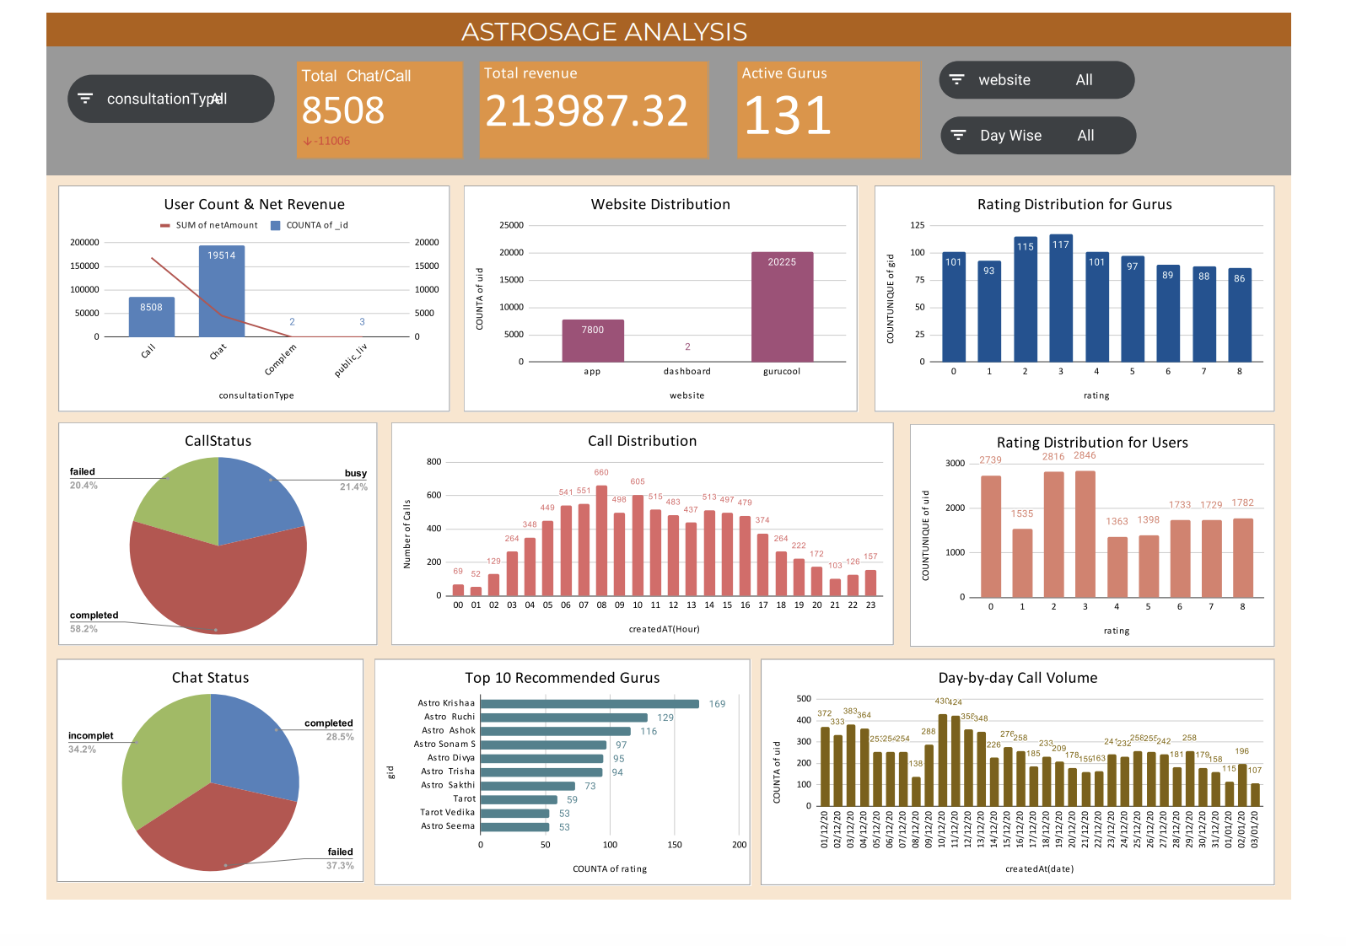

Metrics that should be featured on the final dashboard to enhance business operations and uncover potential issues include:

**Filters:**

1. Consultation Type Filter
2. Website Filter( app,dashboard,gurucool)
3. Day wise Users

Metrics on which these filters act upon are:

* **Total Revenue** : This metric encapsulates the comprehensive revenue accrued from all business activities. It can be segmented to analyze income by various consultation modalities (such as calls, chats, complementary,public_live_call) and across different platforms (including applications, websites, or both). This sophisticated metric serves as a crucial indicator for evaluating overall business performance and effectiveness.
* **Total no. Call/Chats** : This metric represents the cumulative number of customer interactions, including both calls and chats, with data variability based on the selected consultation type in the slicer. Analyzing this metric enables a detailed understanding of customer engagement patterns and preferences, revealing insights into how the volume of calls versus chats shifts according to the chosen consultation type.
* **Active Gurus:** This metric denotes the total number of gurus actively engaging in providing the service within a given period.
* **Website Distribution:** This metric provides a detailed visualization of user engagement on various platforms (such as apps, gurucool, dashboard) on a day-to-day basis. By tracking the number of users interacting with the business daily, it offers critical insights into user’s platform performance, and engagement trends.
* **Call Distribution:** The call distribution data indicates clear patterns in user engagement throughout the day. Peak call volumes occur in the early morning, particularly between 5 AM and 8 AM, suggesting that users prefer to reach out during these hours.
* **Rating Distribution for Gurus :** The rating distribution for gurus reveals a varied landscape of user satisfaction. A significant number of ratings cluster around the lower end, with many gurus receiving scores of 0 to 3, indicating a substantial portion of users are dissatisfied or have had average experiences.
* **Rating Distribution for Users :** The rating distribution for users shows a pronounced tendency toward lower satisfaction levels, with a substantial number of users giving ratings of **0** and **1**. This indicates a significant portion of the user base is dissatisfied with their experiences.
* **Call Status :** The call status report shows a total of 1,270 busy calls, indicating a significant volume of simultaneous communications. In contrast, the completed calls reached 3,453, demonstrating a high success rate in call connections. However, there were also 1,214 failed calls, highlighting areas for potential improvement in call handling and connectivity.
* **Chat Status :** The chat status report reveals that there were 5,535 completed chats, showcasing a reasonable level of successful interactions. However, the number of failed chats stands at 7,255, indicating a significant challenge in maintaining effective communication. Additionally, there were 6,641 incomplete chats, suggesting that many conversations did not reach a resolution, highlighting areas for improvement in the chat support process.
* **Day-by-day call volume :** The user activity data from December 1, 2023, to January 3, 2024, reveals significant fluctuations in call volume. Peaks occurred on December 10 and 11, with 430 and 424 calls respectively, while New Year's Day saw the lowest volume at 115 calls. Overall, the data suggests stable user engagement with notable drops during the holiday period, highlighting the impact of external events on communication activity.
* **Top 10 Recommended Gurus:** The top 10 recommended gurus demonstrate a range of user satisfaction levels, with the highest-rated guru standing out significantly in terms of both engagement and positive feedback. While the top performers exhibit strong ratings, there is a noticeable drop as we move down the list, indicating a disparity in service quality among the gurus.

1. How would you allocate a 1 crore rupee investment to optimize operational efficiency, enhance customer satisfaction, and boost profitability, and what analysis-based recommendations would you offer to support this?

**Ans:** Allocating a 1 crore rupee investment to optimize operational efficiency, enhance customer satisfaction, and boost profitability involves a strategic approach that balances immediate needs with long-term growth. Here’s a detailed breakdown of how you might allocate the investment and the recommendations based on analysis:

1. **Operational Efficiency** (40% - ₹40 Lakhs)

1. Technology and Automation (₹20 Lakhs)

* Invest in Automation Tools: Implement robotic process automation (RPA) to streamline repetitive tasks and improve process efficiency.
* Upgrade Software Systems:Enhance existing ERP or CRM systems for better integration and data management.

1. Process Improvement (₹10 Lakhs)

* Lean Six Sigma Training:Train employees in Lean Six Sigma methodologies to identify and eliminate process inefficiencies.
* Consulting Services:Engage consultants to conduct a process audit and recommend optimization strategies.

1. Infrastructure and Equipment (₹10 Lakhs)

* Upgrade IT Infrastructure:Invest in better hardware and network solutions to ensure reliable and efficient operations.
* Workplace Enhancements: Improve physical workspace to boost productivity and employee satisfaction.

2. **Customer Satisfaction** (30% - ₹30 Lakhs)

1. Customer Experience Enhancements (₹15 Lakhs)

* Omnichannel Support: Develop or enhance omnichannel support systems (integrating chat, email, and social media) for a seamless customer experience.
* Personalization Technologies:Implement tools for personalizing customer interactions based on data insights.

1. Training and Development (₹10 Lakhs)

* Customer Service Training:Provide comprehensive training programs for frontline staff to improve communication and problem-solving skills.
* Customer Feedback Systems:Set up systems to collect and analyze customer feedback for continuous improvement.

1. Loyalty Programs (₹5 Lakhs)

* Design and Implement Loyalty Programs:Develop loyalty and rewards programs to enhance customer retention and satisfaction.

3. **Profitability (30% - ₹30 Lakhs)**

1. Marketing and Sales

* Digital Marketing Campaigns: Invest in targeted digital marketing strategies (SEO, PPC, social media) to drive sales and expand market reach.
* Sales Training: Enhance sales team capabilities with training focused on conversion optimization and customer engagement.

1. Product Development

* R&D for New Products:Allocate funds for research and development of new products or services that meet market needs.
* Product Improvement:Invest in improving existing products based on customer feedback and market trends.

1. Financial Management Tools:

* Implement advanced financial management software to better track and optimize expenditures and revenues.
* Cost-Benefit Analysis:** Conduct thorough analyses to ensure that investments in various areas yield the highest return on investment (ROI).

**Analysis-Based Recommendations:**

1. **Data-Driven Decision Making:** Regularly analyze operational data to identify inefficiencies and areas for improvement. Use key performance indicators (KPIs) to measure the impact of the investments and adjust strategies as needed.
2. **Customer Feedback Integration:** Continuously gather and analyze customer feedback to ensure that enhancements align with customer needs and preferences. Use this data to refine customer experience strategies and improve satisfaction.
3. **Performance Metrics Tracking:** Set up dashboards to monitor the performance of various investments and initiatives. Track metrics such as customer satisfaction scores, operational efficiency ratios, and ROI to gauge success and make data-informed adjustments.
4. **Benchmarking:** Compare your business’s performance against industry benchmarks to identify areas of competitive advantage and areas needing improvement. Use this information to guide strategic investments and optimize resource allocation.
5. **Scalable Solutions:** Invest in scalable solutions and technologies that can grow with your business. This ensures that your investments remain relevant and continue to provide value as your business expands.